
4onse: analysis of Four times Open Non-conventional system for Sensing the Environment

Set-up and installation documentation

Deliverable No. | D7
Due Date | 30.09.2017
Submission Date | 03.10.2017
Deliverable Leader | SUPSI / UOM / IST / UGM
Dissemination Level | PU | Public
Dissemination Level | PP | Restricted to other project participants (including R4D services)
Dissemination Level | RE | Restricted to a group specified by the project (including R4D services)
Dissemination Level | CO | Confidential, only for project and the R4D services
Status | to be continuously updated

4onse project has been fund within the Research for Development program with decision IZ07Z0_160906 / 1
Change log
Version | Date | Amended by | Changes
0.1 | 21-08-2017 | Emeshi Warusavitharana | Structure of the report
1.0 | 22-09-2017 | Dananjaya Bandara, Emeshi Warusavitharana | Content of the report
1.1 | 28-09-2017 | B.H. Sudantha, Emeshi Warusavitharana, Dananjaya Bandara | Final version of the report
1.2 | 02-10-2017 | B.H. Sudantha, Dananjaya Bandara, Emeshi Warusavitharana | Completing the reviewed report

Partners involved in the work execution
Versions | Partner Name | People involved
0.1 | UoM | Emeshi Warusavitharana
1.0 | UoM | Dananjaya Bandara, Emeshi Warusavitharana
1.1 | UoM | B.H. Sudantha, Emeshi Warusavitharana, Dananjaya Bandara
1.2 | UoM | B.H. Sudantha, Dananjaya Bandara, Emeshi Warusavitharana

NOTES:
For comments / suggestions / contributions to this document, contact the Coordinator of 4onse project at massimiliano.cannata@supsi.ch
For more information on the project 4onse, link to http://www.4onse.ch

Contents
Executive summary 6
1 Getting to know the main components 6
2 Setting up the main processing unit 9
3 Setting up the sensors 10
3.1 Assembling the pressure, humidity and temperature sensor 10
3.2 Assembling the wind speed sensor 12
3.3 Assembling the wind direction sensor 13
3.4 Assembling the rain gauge 14
3.5 Assembling the light intensity sensor 16
3.6 Assembling the soil moisture sensor 17
3.7 Assembling the river gauge 18
4 Setting up the power supply unit 19
5 Conclusion 20

Executive summary
This document describes the steps required to set up and run the 4onse environmental monitoring system. Section 1 lists the required items to buid the system. Section 2 describes the steps of setting up the main processing unit. Section 3 elaborates the steps of setting up the sensors of the 4onse system. Finally, the Section 4 describes the steps of assembling the system’s power supply unit.

Getting to know the main components
4onse system is capable for measuring temperature, humidity, wind speed, wind direction, rainfall, light intensity, atmospheric pressure, soil moisture and water level. The system comes with two separate stations. The main station is to measure the weather parameters of temperature, light intensity, soil moisture, atmospheric pressure, humidity, wind speed, wind direction and rainfall. The second station is used as the river gauge to measure the water level. Table 1.1 lists the required items to build the 4onse main station. Table 1.2 lists the required items to build the 4onse river gauge. Please make sure you have all the listed components before continuing.
Table 1.1: Main components of the 4onse main station
No | Item | Description | Qty
Components of the main processing unit
01 | 4onse Main controlling and processing unit | Contains mainly the main controller - Arduino Mega 2560, SD module, RTC – DS1307, GSM module – SIM800 / SIM900, Relay module, Power regulators and other necessary electronic components. | 01
02 | 16 x 2 Alphanumeric LCD | To display the data in the system | 01
03 | 12V DC brushless Fan | For cooling the system | 01
04 | 4onse Printed Circuit Board (PCB) | To connect all the components of the weather station | 01
Components of the power supply unit
05 | 100W Solar Charger | To charge the battery | 01
06 | 30W Solar panel | To charge the battery | 01
07 | 12V, 25Ah rechargeable battery | To provide power to the system and store energ receiving from solar panel | 01
Sensors
08 | DS18B20 sensor | To measure the temperature | 01
09 | BH1750 Light sensor | To measure the light intensity | 01
10 | 4onse Soil moisture module | To measure the soil moisture | 01
11 | BME280 sensor | To measure atmospheric pressure and humdity | 01
12 | ZHIPU wind speed sensor | To measure the wind speed | 01
13 | Anemometer 485 Wind direction sensor | To measure the wind direction | 01
14 | 6465 Davis AeroCone Rain Gauge with Mountable Base | To measure the rainfall | 01
Components required for mounting and housing
15 | Plastic boxes | Box 1 (12”×10”×2”) – To carry the main processing unit  Box 2 (12”×12”×4”)– To carry the power supply unit of the main weather station  Box 3 (10”×8”×2”) – To carry the sensors | 03
16 | Mounting pole with arms and base | Dimensions - 3m height and 25mm diameter  To carry the boxes with components of the main weather station | 01

Table 1.2: Main components of 4onse river gauge
No | Item | Description | Qty
01 | 4onse River gauge controller | Contains Arduino UNO, HC-SR04 ultrasonic sensor, RF transceiver | 01
02 | 10W Solar panel | To charge the battery | 01
03 | 100W Solar charger | To charge the battery | 01
04 | 12V, 7Ah rechargeable Battery | To provide power to the system and store energ receiving from solar panel | 01
05 | 125mm diameter and 4m height PVC tube | To mount the river gauge controller unit | 01
06 | Plastic box | River gauge Box (10”×8”×2”) - To carry the components of the river gauge | 01
07 | Mounting pole with arms and base | Dimensions - 3m height and 25mm diameter  To carry the boxes with components of the river gauge | 01

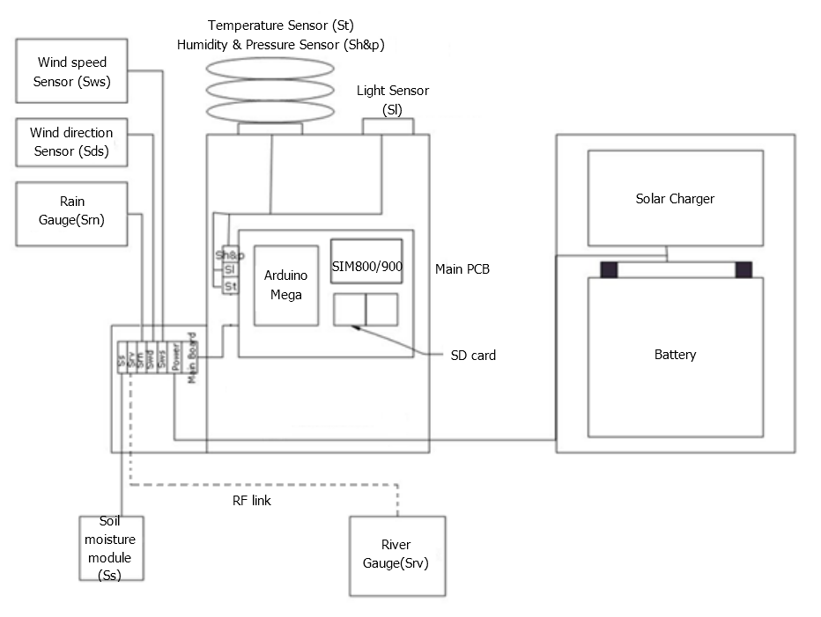
The weather station was developed as an Arduino Mega2560 based embedded system. All the sensors except river gauge is connected to the main system. The river gauge was separately developed using Arduino UNO and necessary electronic modules in order to keep distance between main system and river gauge. The communication between the main system and the river gauge was established using wireless technologies. All the processing and controlling were carried out by Mega2560 and all the data collected at the station is sent to main server using GSM technology. Figure 1.1 shows the block diagram of the 4onse main system architecture.
Figure 1.1: Schematic diagram of the 4onse environmental monitoring sytem

Figure 1.1: Block diagram of the 4onse main system architecture

Setting up the main processing unit
Required Components
- 4onse main processing unit
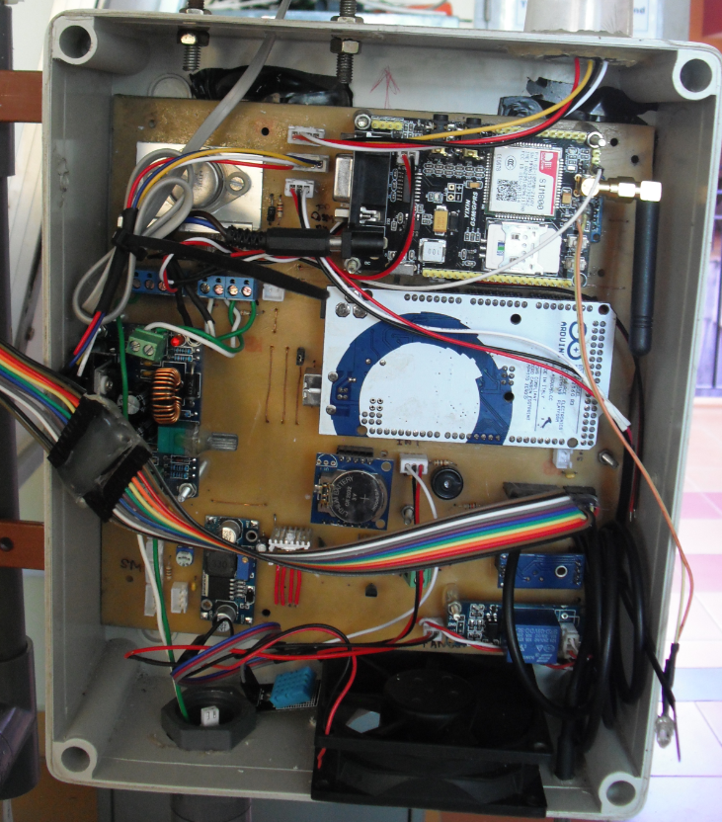
Figure 2.1: 4onse main processing unit

Method of assembling the main processing unit
- Programming the Arduino Mega
  - The 4onse system comes with a preprogrammed Arduino Mega. Once you connect all the components correctly and powered up the system it will work perfectly.
  - The following steps include how to upload a code in to the Arduino Board
  - First you need to download Arduino IDE using the link - http://arduino.cc/en/main/software and installed it to your computer.
  - Then you can connect Arduino to the computer and Run the Arduino software which you installed.
  - You need to select the right port, you can follow the instruction given in above link.
  - Now you can type the code and verify them
  - Finally you can upload them to the board. When it is uploading, the LED on the Arduino will blink.
- This main controlling and processing unit comes with attached pre-programmed Arduino Mega2560, SIM800 / SIM900 GSM module, RTC, SD module, relay module, all necessary power regulatores and all the necessory electronic components. To set up the system, connect all the sensors as described in this user manual.

Setting up the sensors

Assembling the pressure, humidity and temperature sensor
Required Components of the pressure and humidity sensor
- BME280 pressure and humidity sensor
- DS18B20 temperature sensor
- 6 inch U bolts – 1
- Backing plate – 1
- Lag screws - 2
- Flat washers – 2
- Lock washers - 2
- Hex nuts - 2
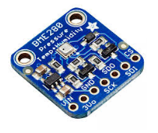
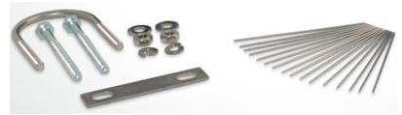
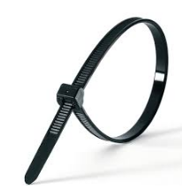
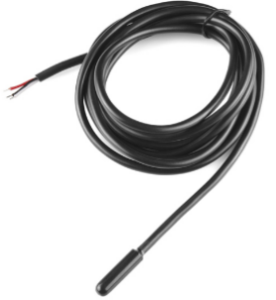
- Cable tie
U Bolt
¼“ Flat washers
¼“ Hex nuts
BME280 sensor
¼“×3“ Lag screws
¼“ Lock washers
Cable tie
Backing plate
DS18B20 sensor

Figure 3.1.1:Components of pressure and humidity sensor

Method of assembling the pressure, humidity and temperature sensor
- The pressure, humidity and temperature sensors needs to be equipped with a windshield / heat shield.
- To make the windshield / heat shield, first take 3 plastic plates.
- Take one plastic plate and make some holes on it.
- Then fix the sensors with ½ inch bolts and fix the connectors of the sensor with glue. This will reduce the possibility of creating any loose connections.

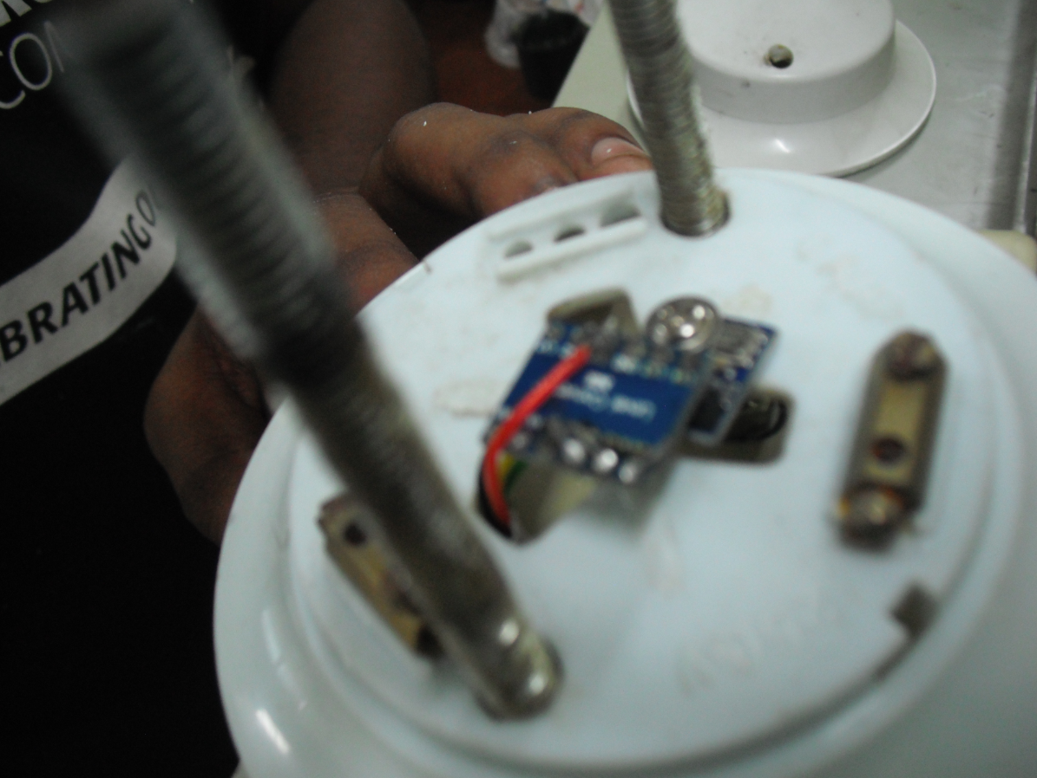
Figure 3.1.2: Fixing pressure and humidity sensor to the plastic plate

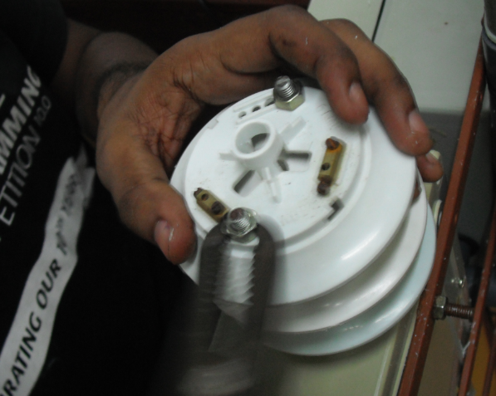
- Next, fix the remaining two plastic plates on the first plastic plate equipped with sensors. For that, make some holes on them parallel to the holes of the first plastic plate and fix them with U bolts as shown following figure. Now the windshield / heat shield is finalized.

Figure 3.1.3: Fixing remaining plastic plates

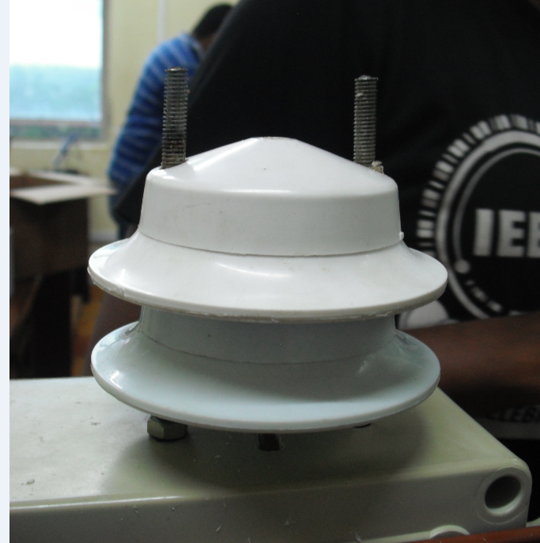
Figure 3.1.4: Finalized wind sheild / heat sheild with pressure, humidity & temperature sensors

Assembling the wind speed sensor
Required components
- ZHIPU wind speed sensor
- 1.5 inch Bolts - 2
- Hex nuts – 2
- Flat washers – 2
- Cable ties
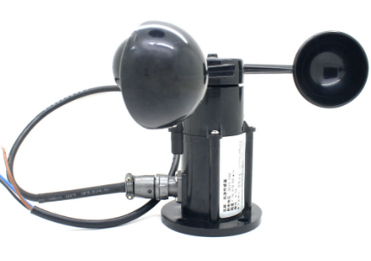
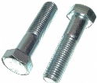
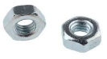
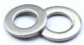
ZHIPU 0-5V voltage wind speed sensor

Cable tie

Hex nuts

Flat washers

1.5 inch bolts

Figure 3.2.1:Components of the wind speed sensor

Method of assembling the wind speed sensor
- Fix the wind speed meter to the mounting pole using nuts and 1.5 inch bolts.
- Use the Cable ties to fix the sensor connector from the main PCB to the mounting pole
- Finally, plug the fixing end of wind speed sensor its dedicated slot in the PCB.

Assembling the wind direction sensor
Required components
- Anemometer 485 wind direction sensor
- 1.5 inch Bolts - 2
- Hex nuts – 2
- Flat washers – 2
- Lock washers - 2
- Cable tie

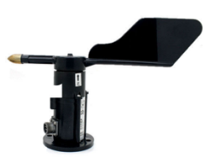
CSS-HS 4-20mA Wind direction sensor
Cable tie

Hex nuts

Flat washers

1.5 inch bolts

Lock washers

Figure 3.3.1:Components of the wind direction sensor

Method of assembling the wind direction sensor
- Fix the wind direction sensor to the mounting pole using nuts and 1.5 inch bolts.
- Use the Cable ties to fix the sensor connector from the main PCB to the mounting pole.
- Finally, plug the fixing end of the wind direction sensor to its dedicated slot in the PCB.

Assembling the rain gauge
Required components
- 6465 Davis AeroCone Rain Gauge with Mountable Base
  - Rain collector cone latched onto base
  - Base with tipping mechanism and 40’ (12 m) cable
  - Metric adapter
  - Debris Screen
  - 16 3.5” (9 cm) bird spikes (optional)
- U-bolt
- Backing plate
- Lag screws – 2
- Flat washers – 2
- Lock washers – 2
- Hex nuts – 2
- Cable tie
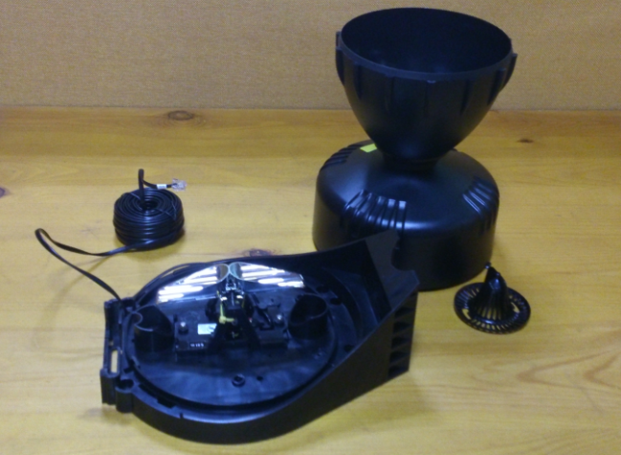
Rain collector cone
Debris screen
40‘ cable
Base
Tipping mechanism

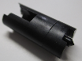
U Bolt
¼“ Flat washers
¼“ Hex nuts
3.5“ bird spikes (16)
¼“×3“ Lag screws
¼“ Lock washers
Cable ties
Metric adapter
Backing plate

Figure 3.4.1:Components of the rain gauge
Method of assembling the rain gauge
- First remove the cone from the base by rotating the base until the latches on the cone line up with the latch openings in the base, then lifting the cone away from the base.
- Carefully cut and remove the plastic tie which holds the tipping spoons in place during shipping. (Figure 3.4.2)
Plastic tie

Figure 3.4.2: Cut and remove the plastic tie

- The rain collector tipping mechanism contains a standard measurement weight magnet that takes measurements in 0.01” for every tip of the spoons. For the greatest accuracy, install the metric adapter so that the rain collector will take measurements in 0.2 mm for each tip of the bucket.
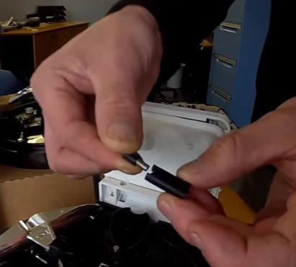
- For that, remove the standard measurement weight magnet which locate between the arms of the tipping mechanism. As shown in Figure 3.4.3, insert it to the metric adapter and locate it again between the arms of the tipping mechanism.

Figure 3.4.3: Insert the weight magnet to the metric adapter

- Then fix the rain collector to the base and use U bolt, nuts, washers, screws, backing plate and cable ties to fix the rain gauge to the mounting pole.
- If needed, fix bird spikes around the rain collector to prevent birds land on the rain collector.
- Finally, plug the fixing end of the rain gauge to its dedicated slot in the PCB.

Assembling the light intensity sensor
Required components
- BH1750 Light sensor module
- Transparent cup
- Glue

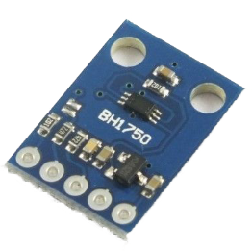
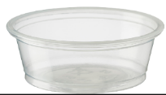
BH1750 Light sensor module
Transparent cup

Figure 3.5.1:Components of the light intensity sensor

Method of assembling the light intensity sensor
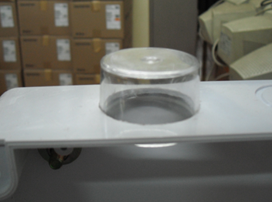
- As shown in Figure 3.5.2, cut a hole in the sensor box to dip the transparent cup.

Figure 3.5.2: Dip the transperant cup to the sensor box’s hole

- Then insert the BH1750 Light sensor into the transparent cup and bond it to the transparent clup using glue (Figure 3.5.3)
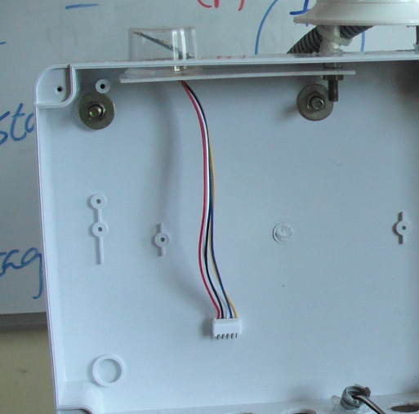

Figure 3.5.3: Bond the light sensor to the plastic cup

- Then plug the connection of the sensor to the relevant slot in the PCB.

Assembling the soil moisture sensor
Required components
- 4onse soil moisture module
- Connection cables and cable ties
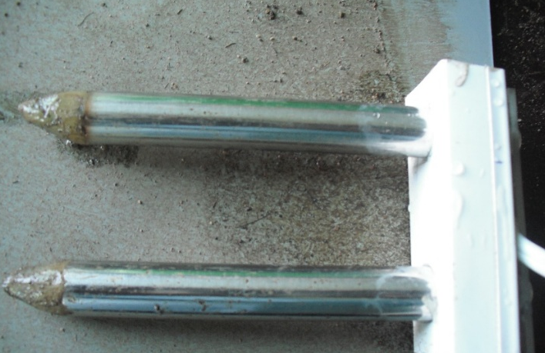

Figure 3.6.1: 4onse soil moisture module

Method of assembling the soil moisture sensor
- Plug the connection of the 4onse soil moisture module to the relevant slot in the PCB.
- Use the Cable ties to fix the module connector from the main PCB to the mounting pole

Assembling the river gauge
Required components
- 4onse river gauge module
- Power supply unit
- Mounting pole
- Transmitter – APC 220
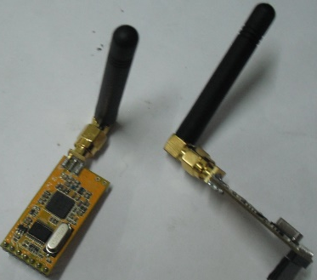

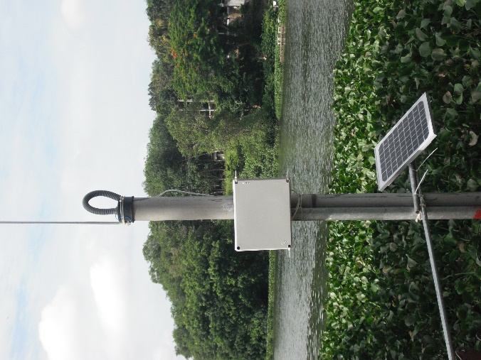

Figure 3.7.1: APC220 transmitters

Figure 3.7.1: 4onse river gauge

Method of assembling the river gauge
- Fix the 4onse river gauge module, Power Supply unit and Transmitter to the mounting pole using bolts and nuts
- Then plug Transmitter to the River gauge to transmit the readings automatically to the main weather station.
- Then connect the power supply to the River gauge.

Setting up the power supply unit
Method of setting up the power supply unit
- Figure 4.1 illustrates the power supply plan of the main system.
- The main PCB of the system comes with soldered voltage regulators
- First make sure solar panel controller is turned off.
- Then, connect the solar panel controller to the solar panel
- Next, connect battery to the solar panel controller
- Finally, connect solar panel controller to the PCB and turn it on.
+15V DC
regulated
+12V DC
Unregulated
+9V DC
regulated
+5V DC
regulated
+5V DC
regulated
Solar Panel
30W
Solar panel voltage controller
Sealed type Lead/Acid battery 25AH
Linear Voltage Regulator
GSM SIM800 / SIM900
Arduino Mega2560
Local Regulator
Local Regulator
Relay module, Fan etc
Sensor modules, LCD etc
Stepup Regulator
Wind Speed Wind Dir Sensors

Figure 4.1: Power plan of the main system

Conclusion
The main objective of developing the 4onse system is to introduce a fully open, low cost and non-conventional system to sense the environmental parameters. The entire system, including the river gauge can be built at a cost less than 700 USD. When deploying the the 4onse system in the field, it is recommended to follow the WMO standards on siting the weather stations and river gauges.

Please start with version number 0.1. Any further minor review will increase the version number by 0.1 while a major review will increase the version by 1.0.

